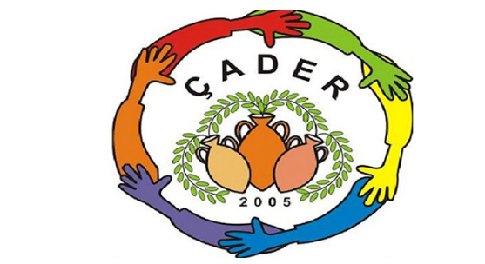

ÇATALKÖY Development and Culture Association
Şht. Kamil Dimililer Cd. Çatalköy 99370 GİRNE
cader2005@outlook.com

The Çatalköy Development and Culture Association was founded in 2005 under the chairmanship of the Founding President Sezay Özgüm with 6 founding members. Hasan Varoğlu, Ali Coşansel, Devrim Karaman, Beraat Varoğlu, Aytekin Bağcıer and Gözde Özerk.

The aim of the association is to raise awareness and to engage in social, cultural and environmental issues and to develop educational activities; to contact and exchange information with other local institutions and those in foreign countries; to produce joint projects.
In 2005 ÇADER was originally situated in the olive oil mill in the village but in 2007 the current building was allocated by the Ministry of National Education. The building was repaired and refurbished by ÇADER under the approval of the Ministry and has served as our headquarters since 2009. “Village Women Courses” , for women in our region, are held at the association building and a teacher trainer is regularily assigned by the Ministry of National Education for this purpose.
Society Activities:
2005 Youth exchange, environmental visits to Latvia and Lithuania, for “Environmental Problems in the EU”
2009/2010 “Local Effort, Global Outcomes”, an EU Commission project aimed at raising awareness of several global issues within the local community and demonstrating similar problems and solutions on a global level. ÇADER’s first EU Project and the first Civil Society project in the village.
The Northern Cyprus Children's Environment Conference was held in 2009 and 2010 and hosted by the Acapulco Hotel.
In 2010, the "Say No to Plastic Bags" campaign was conducted in the super markets of the region with cloth bags being distributed to shoppers as alternatives.
In 2018, the "Environment and Me" was created for environmental awareness raising under the umbrella of ÇADER, an ongoing task.
In December 2018 a new committee was elected under the presidency of Pervin Özgeçen with Neriman Soyumert, Irene Raab Marancos, Sevlay Ramadan and Dürye Yırık.
In May 2019, within the scope of the EU, Grow Civic supported "Domestic Waste Reduction, Inter-Village Cooperation" project, villages in Germany,similar in size and populations to Çatalkoy wrere visited in order to learn how they deal with household waste.
The project "Reaching Children through Culture and Art" approved by the Department of Culture in July, August and September 2019 was realised.
February 2020 (currently) “Web based Handbook on General Environmental Education in Preschool and Primary Schools” project is funded by the EU’s Grow Civic initiative and has been approved by the Education Department.
Following the fact finding mission to Germany, ÇADER began planning a strategy to separate household waste in the village. By August 2020, a pilot scheme was set up by ÇADER and the Municipality to enable the collection of separated and cleaned plastic waste. Plastics are sorted into different coloured bags and bundled paper and cardboard is collected, garden waste can be shredded to form mulch or to be used as the basis for composting. The "Yellow-Blue" bag Recycling Plastic Separation Pilot Scheme, initiated by ÇADER with the cooperation of Çatalköy Municipality and a plastics recycling plant in Haspolat is continuing.
Participating in the annual village festival and continually hosting presentations on relevent topics in society
ÇADER continues to work on projects related to the environment, nature, art and culture and is supported by 110 members.
We encourage and invite other associations and individuals to participate in our waste separation efforts, please contact us through facebook or email on cader2005@outlook.com

