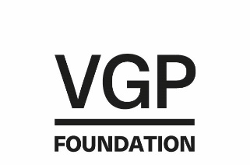
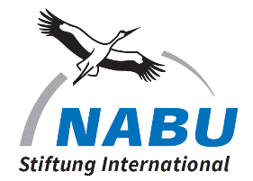
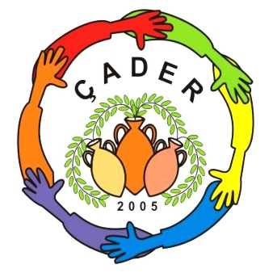
Project for a Nature Protection Campaign in the northern part of Cyprus

Three Villages Go Green – Çatalköy, Arapköy, Esentepe

Background

ÇADER is a non-profit civil society organisation founded in 2005 and has currently 107 members. Its members are mainly women and they concentrate on environmental activities under the motto: “The Environment and Me”
Members are from all walks of life from accountants to meteorologists and housewives to bankers. Their numbers include social workers, administrators and teachers. A blend of skills which has so far proven successful in executing a series of projects, funded by USAID, the EU and central government.
They work very closely with the local authorities and the schools which service the villages of Catalköy, Arapköy and Esentepe. These three villages cover an area of 75 km² and count for about 8.000 inhabitants. They are situated in the foothills of the Pentadactylos Mountain Range, a designated Natura 2000 area and an IBA.

Main environmental activities in the past include: Children’s Environmental Conference, schools were invited to prepare environmental projects, the children had the chance to present their ideas in a conference setting to their peers. This was carried out for two consecutive years. The “No to Plastic” campaign was aimed at school children and shoppers in the supermarkets. Adult shoppers were interviewed by our schoolchildren and then offered a reusable cloth bag in place of the plastic shopping bag. A rags for bags exercise continues, women are sewing shopping bags from old materials and selling them as plastic bag alternative at markets. Local school children join the Saturday club “The Environment and Me” where they have fun while receiving environmental education: making paper, sorting waste, planting flowers, preparing their own glue. Currently a composting, mulching and waste separation programme is in force, a cooperation with the municipality to inform and educate villagers to act more responsibly with their waste. This is a direct result of a study visit to Germany by ÇADER and the acquisition of a professional wood chipping machine. With the schools there is a cooperation to provide teachers and pupils with ongoing environmental education with the guidance of a European professional teacher trainer, organized by ÇADER.

Experience shows, that nature protection needs to be explained in detail to children, adults and teachers alike to improve conservation activities. There is a big lack of basic environmental knowledge compared to European countries. The individual’s role in nature conservation has not been properly understood yet. If the adults don’t know, how can the children learn it? It is proven, that children are able to take responsibility at a very young age, so we have to introduce them to nature conservation latest in primary school. There is a need to demonstrate how nature protection works for every individual person and that it starts in one’s own garden, in the field behind the house in the mountains above and along the sea. Through grassroots interactions the public gets educated and encouraged to change their habits. This way the duty bearers might get nudged in the right direction. So far, ÇADER has managed to establish a good working relationship with the Ministry of Culture and Education, the Ministry of Tourism and Environment, the Municipality of Catalköy, the headmasters of the local schools and the villagers. This puts ÇADER in a strong position as an advocate for change.

The aim is to encourage nature protection at a grassroots level to make three Cypriot villages more avi- fauna friendly and become a model for other villages to follow.
This will be reached through education, habitat improvement and public outreach:

Education is focused on raising awareness and increasing knowledge of the importance of biodiversity and the conservation of wildlife and all natural resources (soil, water, air etc.) and the adverse effects of climate change and the need of adaption strategies.
According to the target groups, school children, students, local hunters, gardeners and garden owners, sports clubs, families, women’s circles, these topics will be introduced and explained using the appropriate language and suitable methods.

Activities:
Organising school field trips (some with parents) under topics like insect photo hunt,
nature at night, bird watching, litter collection along the beach and tree planting/watering.
Providing teachers with material (magnifying glasses, bug collecting tools, clip boards) Hosting painting competitions at the schools.
Planting insect attracting plants in the school gardens.
Making individual clay pots for planting insect attracting flower seeds.

Presentations to villagers, hunters, university students, women’s circles about relevant topics for example climate change, the need for biodiversity, what does Natura 2000 and IBA mean. It is important, that these presentations will be followed by immediate discussions. Introduction to SDG`s Sustainable Development Goals on a basic level will emphasize the importance of the individual and his personal actions.

Workshops for gardeners: about composting, mulching, about plants for insects and birds, danger of insecticides; for families: building insect hotels, nesting boxes and feeding stations. Field trips for villagers with the aim of appreciating nature and wildlife with local experts for bird watching, botany

Habitat improvement could start on every villager’s balcony or garden and expand from there. The local municipality will be invited to participate in increasing the volume of trees and shrubs planted in municipal open areas. The logical step from this small-scale project is to approach the forestry department to allocate land for afforestation.

Activities:
Cleaning areas from litter.
Planting trees and shrubs on private land within the village and within the boundaries of the municipality and on land allocated by the forestry department.
Placing nesting boxes and insect hotels in private gardens, municipality land and areas allocated within the boundaries of the three villages by the forestry department.

Public outreach materials will be produced to give information. Webpage established, photo and painting exhibitions and family outdoor activities will be organized. Ongoing newspaper and social media coverage for more awareness, a bigger audience and to promote the activities in and around the villages. Important is collaborating with other like-minded CSO’s. Encouraging the local university to participate in the project.

Activities:
A website will be prepared. The website will function as an information platform and shall provide didactic educational material where teachers and parents as well as children can find over time more and more nature related articles, links, and DIY instructions. It would be great to develop this site as an environmental education resource.
Leaflets and posters about migrating birds, biodiversity and endemic species will be prepared and distributed through schools and local businesses. Keeping social media updated. Participating in nature related meetings and on platforms on the island. Sharing experience with other CSO’s. Keeping good connections with general media and local institutions.

Expected outcomes
A year’s hard work will have created more public awareness of the importance of nature conservation in the foothills of the Pentadaktylos Mountains. More school children will be aware of the importance of birds and insects in their environment and that their individual behaviour is a part of the whole. Responsibility and ownership will be engendered to these youngsters. Teachers involved will be sensitised for nature and will have more knowledge and they will be established providing teachers, students and members of public with good information about nature. Local hunters will be more knowledgeable.
The number of trees and shrubs planted, nest boxes established and insect hotels positioned will be published and those numbers might attract other villages to compete.
Newly established volunteers will carry on the good work, villagers will continue with their new found knowledge and the members of ÇADER will continue with some of the activities and workshops, tree planting, building and hanging nesting boxes and insect hotels will become an annual event.

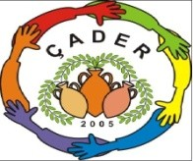
Çatalköy, Association for Development and Culture, Sehit Kamil Demililer Cad. No 41, 99370 Çatalköy

Contact : Pervin Özgecen, Chairwoman e-mail : cader2005@outlook.com

